东华学报
2025年第42卷第4期
──────────────────────────────
本期责编: 编辑部 | 2025年11月24日

DOI: 10.19884/j.1672-5220.202404007
Citation: WU X O, SONG W, CHEN S, et al.. Preparation and Properties of Bacterial Cellulose / Hyaluronic Acid Oral Disintegrating Films [J]. Journal of Donghua University (English Edition), 2025, 42(4): 339-347.
WU Xiaoyan, SONG Wei, CHEN Shuang, XIAO Ru
1. Preparation and Properties of Bacterial Cellulose / Hyaluronic Acid Oral Disintegrating Films
────────────────────
作者说链接/OSID

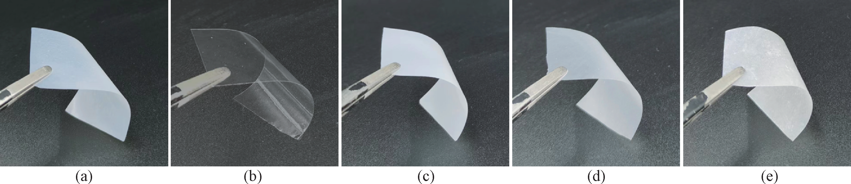

DOI: 10.19884/j.1672-5220.202406006
Citation: ZHU Z X, ZHANG X. Development of Electrochemical Sensor for Cefadroxil Antibiotic Based on Conductive Carbon Black Decorated with Tetrabutylammonium Tetrafluoroborate [J]. Journal of Donghua University (English Edition), 2025, 42(4): 348-357.
ZHU Zongxian, ZHANG Xuan
2. Development of Electrochemical Sensor for Cefadroxil Antibiotic Based on Conductive Carbon Black Decorated with Tetrabutylammonium Tetrafluoroborate
────────────────────
作者说链接/OSID

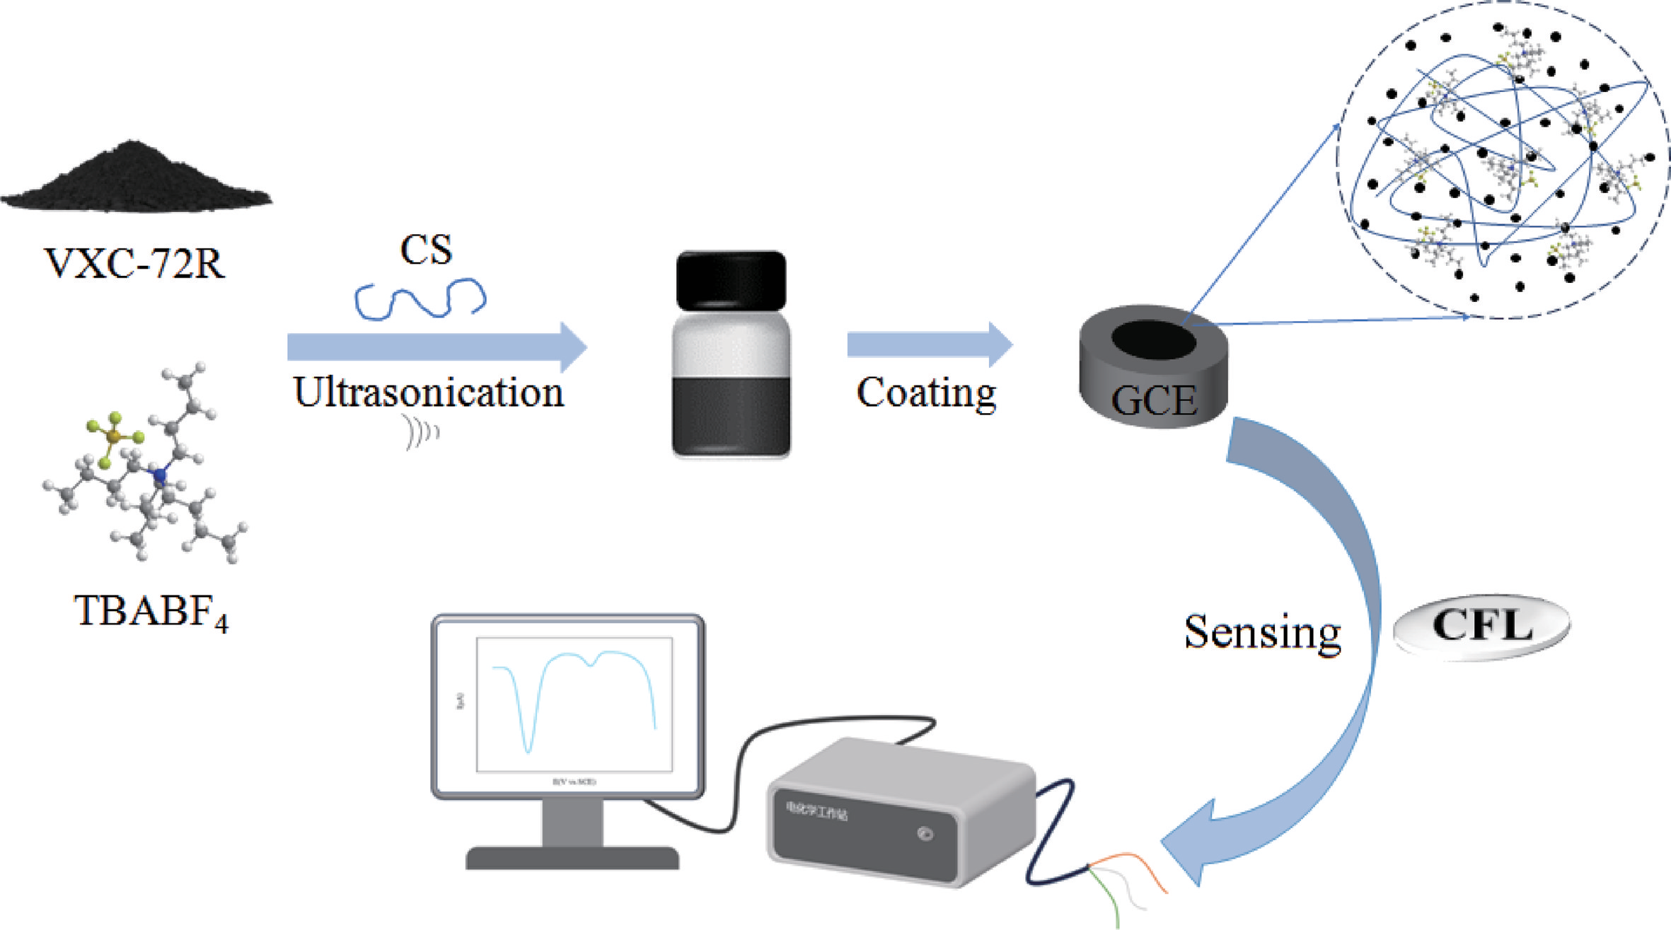

──────────────────────────────
感谢您的阅读！欢迎引用本文内容
© 2025 东华大学学报 版权所有

